|  |  |  |  |  |
| --- | --- | --- | --- | --- |
|  | Bansilal Ramnath Agarwal Charitable Trust's  Vishwakarma Institute of Information  Technology    **Department of**  **Artificial Intelligence and Data Science** | | | |
| Name: Siddhesh Dilip Khairnar | | | | |
| Class: TY | Division: B | | | Roll No: 372028 |
| Semester: V | | Academic Year: 2023-2024 | | |
| Subject Name & Code: Image Processing: ADUA31205(B) | | | | |
| Title of Assignment: Set up different image processing libraries in Python. Perform basic image manipulations (resizing, cropping, negating) and transformations (linear, affine transformations) | | | | |
| Date of Performance: 08-08-2023 | | | Date of Submission: 15-08-2023 | |

**ASSIGNMENT NO. 1**

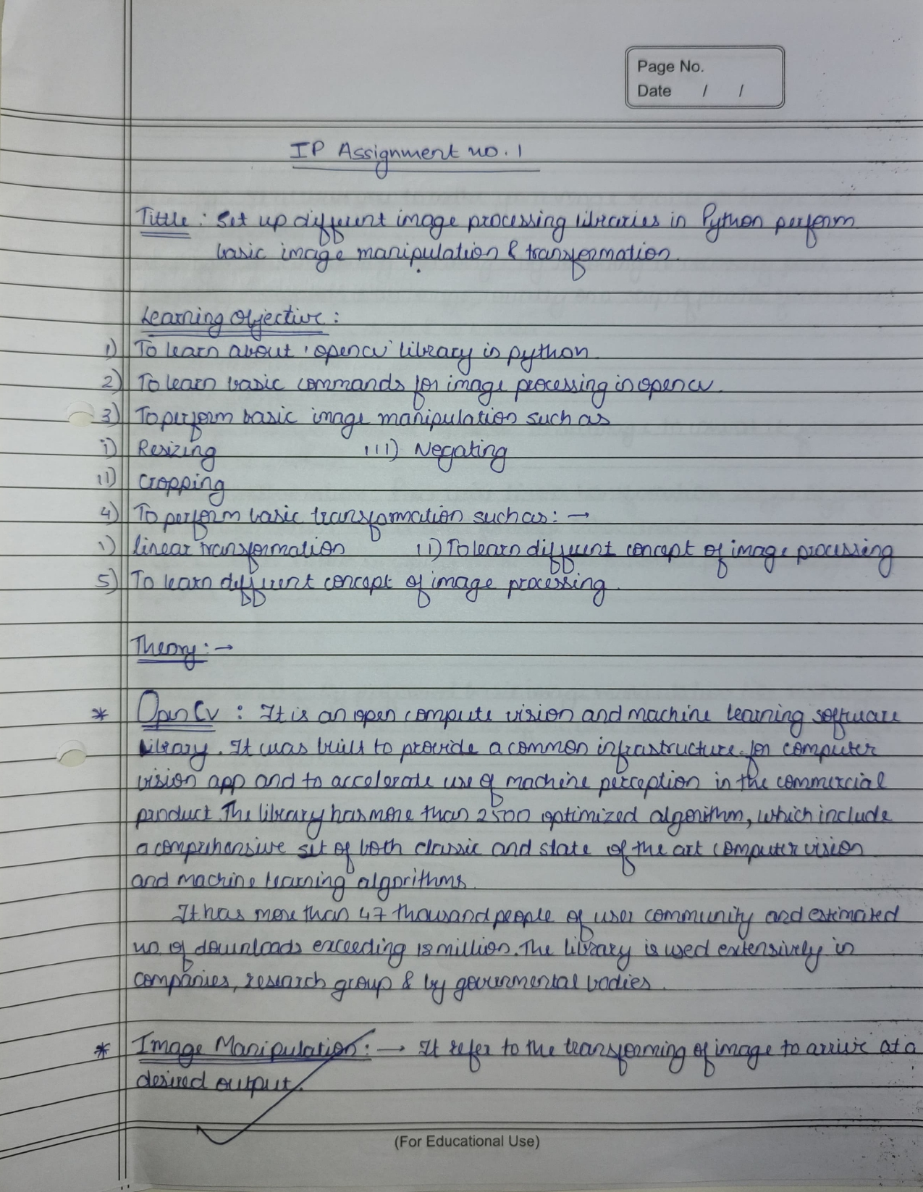

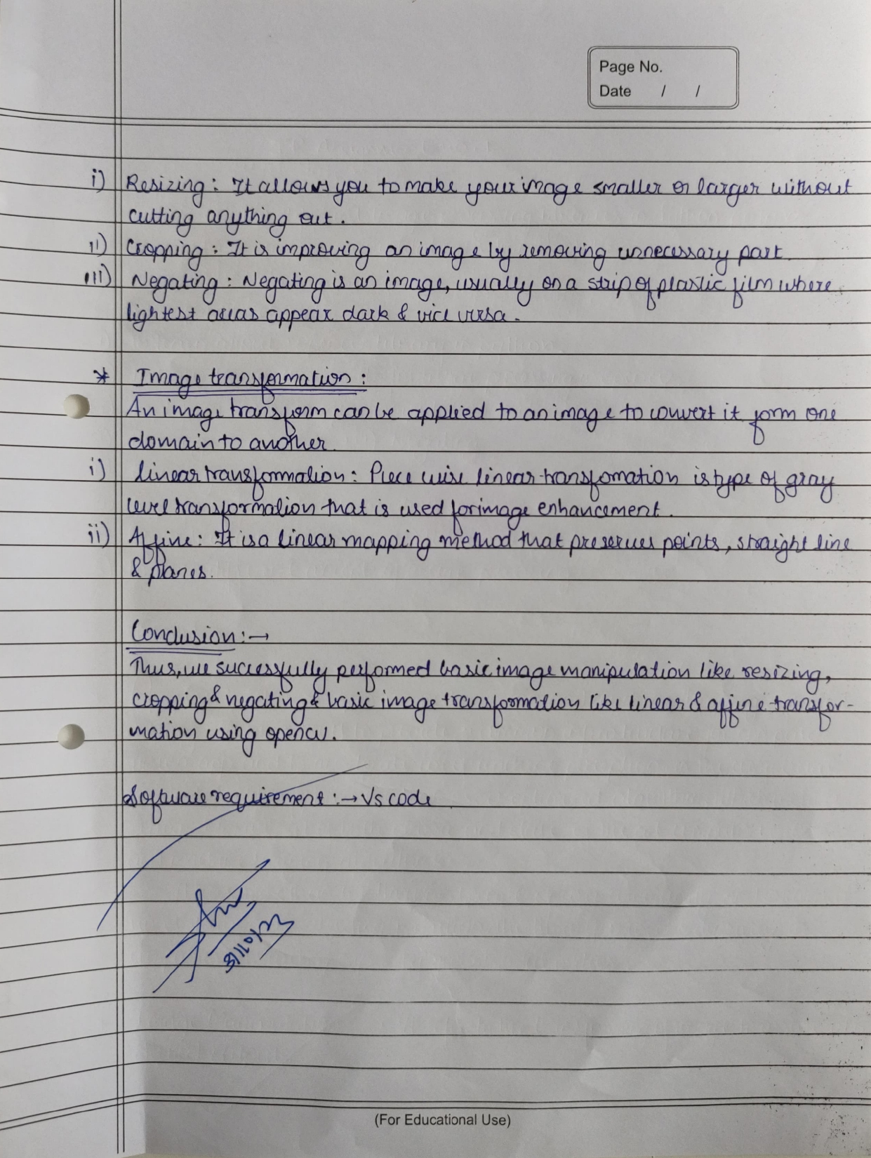

Program Code:

|  |
| --- |
| # 1.Loading and Displaying an Image    # import the necessary packages import cv2  # load the image and show it  image = cv2.imread("D:\MY FILES\wallpaper\BLACK HOLE.jpg") window_name = 'image'  cv2.imshow(window_name, image)    # print the dimensions of the image print(image.shape)    # 2. Resizing an Image using Python and OpenCV    # we need to keep in mind aspect ratio so the image does # not look skewed or distorted -- therefore, we calculate  # the ratio of the new image to the old image  r = 100.0 / image.shape[1]  dim = (100, int(image.shape[0] * r))  # perform the actual resizing of the image and show it resized = cv2.resize(image, dim, interpolation = cv2.INTER_AREA) cv2.imshow("resized", resized)    # 3. Rotating an Image using Python and OpenCV  # finding centre  (h, w) = image.shape[:2] center = (w / 2, h / 2)  # rotate the image by 180 degrees  M = cv2.getRotationMatrix2D(center, 180, 1.0) rotated = cv2.warpAffine(image, M, (w, h)) cv2.imshow("rotated", rotated)    # 4. Cropping an Image using Python and OpenCV    # crop the image using array slices cropped = image[70:170, 440:540] cv2.imshow("cropped", cropped) cv2.waitKey(0) |

Output:

